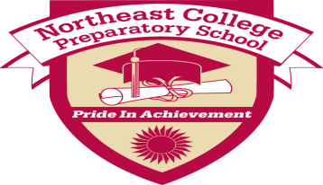
Northeast College Preparatory School Lesson Plan
Teacher(s): Mr. Holloway Grade: Middle School, 7/8
Subject(s):Technology Date of delivery: 1/11 – 1/18 (Classes
meet every other day)

- Common Core Learning Standards Addressed:

Writing Standards: Standard 6- Use Technology, including the internet, to produce and publish writing and to interact and collaborate with others.
NYS Standards: Standard 5 - Technology

- Learning Target(s): (What will the students know and be able to do as a result of this lesson?)

Students will be able to use Microsoft PowerPoint effectively to conduct a presentation.

- Essential Question(s)/Guiding Question(s):

How do you use Microsoft PowerPoint effectively, to conduct a presentation?

- Higher Level Thinking Questions to be used during the lesson:

How do you make your presentation visually appealing to your audience?

- Bridge/Connections/Hook:

When used correctly, Microsoft PowerPoint can be used as a great visual aid when conducting a
presentation.

- Materials/Resources/Technology Integration:

Computer w/internet access.

- Mini Lesson/Process/Procedure:

Go over the activity!
Go over different icons/parts of Microsoft PowerPoint!

- Work Time/Activities/Tasks: (What learning experiences will students engage in? How will you use these learning experiences or their student products as formative assessment opportunities?)

Students will be working on the activity given to them! (How to do Something)

- Access for All: (How will you ensure that all students have access to and are able to engage appropriately in this lesson? Consider all aspects of student diversity.)

Making sure students stay focus on their work over the three classes I provide them to complete the
activity.

- Homework/Extensions/Enrichment:

N/A

- Formative Assessment Criteria for Success: (How will you and your students know if they have successfully met the outcomes? What specific criteria will be met in a successful product/process? What does success on this lesson’s outcomes look like?)

Going over exemplar presentations!

- What adjustments will be made for students that do not meet the Criteria for Success?

We will continue to use Microsoft PowerPoint throughout the year to build their skills up!

Reflections:
- How does this lesson reflect academic rigor?

Students need to demonstrate on how to use Microsoft PowerPoint effectively. Students will need to meet criteria from the teacher.

